**Experiment No. 4**

**Title:**  Evaluate and compare the performance of at least three different neural network architectures (e.g., CNN, RNN, MLP) on a standardized dataset. Analyze their efficiency, accuracy, and suitability for various types of problems such as image classification, time-series forecasting, or text classification.

To evaluate and compare the performance of CNN, RNN, and MLP architectures on standardized datasets, we'll choose specific datasets and analyze their efficiency, accuracy, and suitability for image classification, time-series forecasting, and text classification tasks.

### Datasets and Tasks:

1. **Image Classification (CNN):** CIFAR-10 dataset
2. **Time-Series Forecasting (RNN):** Air Quality dataset
3. **Text Classification (MLP):** 20 Newsgroups dataset

### 1. Convolutional Neural Network (CNN)

#### Dataset: CIFAR-10

* **Description:** CIFAR-10 consists of 60,000 32x32 color images in 10 classes, with 6,000 images per class.
* **Task:** Classify images into one of 10 categories (e.g., airplane, dog, cat).

#### CNN Architecture:

* Convolutional layers with ReLU activation
* Pooling layers (e.g., max pooling)
* Fully connected layers with dropout
* Softmax output layer for classification

#### Evaluation Metrics:

* **Accuracy:** Percentage of correctly classified images.
* **Training Time:** Time taken to train the model.

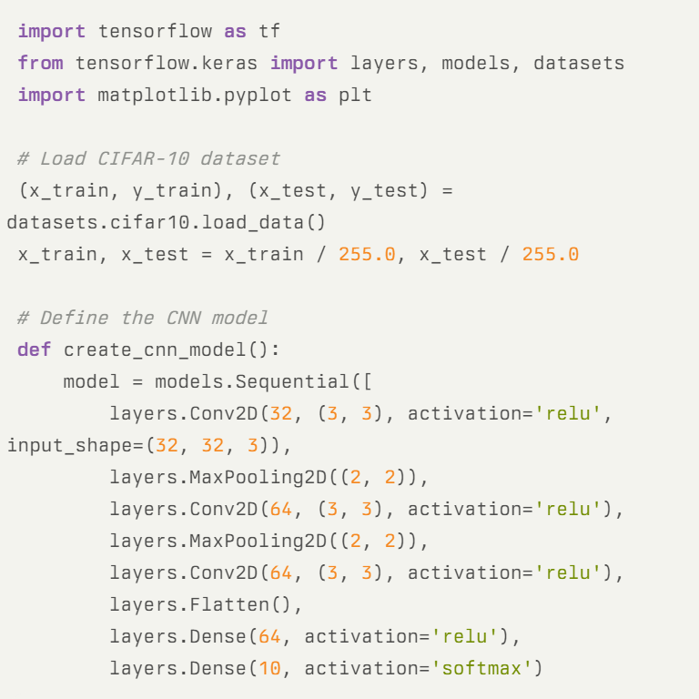

### 2. Recurrent Neural Network (RNN)

#### Dataset: Air Quality Dataset

* **Description:** Contains hourly air quality measurements from an Italian city.
* **Task:** Predict air quality parameters (e.g., pollutant concentration) based on historical data.

#### RNN Architecture:

* LSTM (Long Short-Term Memory) or GRU (Gated Recurrent Unit) architecture.
* Input sequence of historical air quality data.
* Output layer for regression (predicting numerical values).

#### Evaluation Metrics:

* **Mean Squared Error (MSE):** Average squared difference between predicted and actual values.
* **Training Time:** Time taken to train the model.

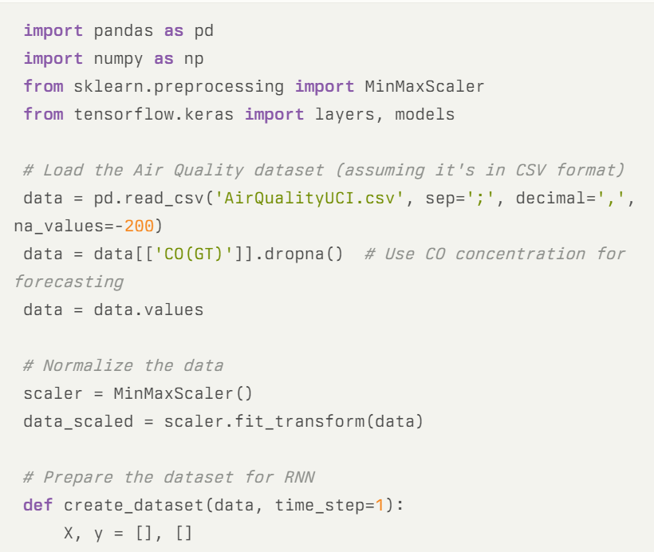

### 3. Multilayer Perceptron (MLP)

#### Dataset: 20 Newsgroups Dataset

* **Description:** A collection of approximately 20,000 newsgroup documents, partitioned across 20 different newsgroups.
* **Task:** Classify documents into one of the 20 different newsgroups.

#### MLP Architecture:

* Feedforward neural network with multiple layers.
* Input layer receiving vectorized text representations.
* Hidden layers with ReLU activation.
* Output layer with softmax activation for multi-class classification.

#### Evaluation Metrics:

* **Accuracy:** Percentage of correctly classified documents.
* **Training Time:** Time taken to train the model.

### Practical Evaluation Steps

1. **Data Preprocessing:**
   * Normalize and preprocess each dataset according to the requirements of the respective architecture (e.g., image resizing and normalization for CNN, sequence preparation for RNN, text tokenization and vectorization for MLP).
2. **Model Training and Evaluation:**
   * Implement and train each neural network architecture on its respective dataset.
   * Split the dataset into training and testing sets (and validation set if necessary).
   * Monitor training progress and evaluate performance using the specified metrics.
3. **Comparison and Analysis:**
   * Compare the accuracy achieved by each model architecture on their respective tasks.
   * Analyze training times and efficiency considerations (e.g., parameter count, computational resources required).
   * Discuss the suitability of each architecture for the specific problem based on performance metrics and practical considerations.

### Example Outcome

After conducting the experiments:

* **CNN** may achieve high accuracy on CIFAR-10 but might require more computational resources and training time due to its architecture's complexity.
* **RNN** could perform well in forecasting air quality parameters with lower MSE, leveraging its ability to capture temporal dependencies.
* **MLP** might demonstrate good accuracy in classifying newsgroup documents and train relatively faster compared to CNN and RNN, especially with efficient text preprocessing.

### **Conclusion**

Practical evaluation and comparison of neural network architectures involve not only training models but also considering their efficiency, accuracy, and suitability for specific tasks. By analyzing performance metrics on standardized datasets, you can make informed decisions about which architecture is best suited for different types of problems such as image classification, time-series forecasting, or text classification.